UNITED STATES
SECURITIES AND EXCHANGE COMMISSION
WASHINGTON, D.C. 20549

FORM 8-K

CURRENT REPORT
PURSUANT TO SECTION 13 OR 15(d) OF THE
SECURITIES EXCHANGE ACT OF 1934

Date of Report (Date of earliest event reported): July 24, 2026

ZW Data Action Technologies Inc.
(Exact Name of Registrant as Specified in Charter)

Nevada |  | 001-34647 |  | 20-4672080
(State or Other Jurisdiction of Incorporation) |  | (Commission File Number) |  | (IRS Employer Identification No.)

8/F. 29 Des Voeux Road Central, Central,
Hong Kong Special Administrative Region of the People’s Republic of China

(Address of Principal Executive Offices and Zip Code)

Registrant’s telephone number, including area code:

+852 2669-8078

(Former Name or Former Address, if Changed Since Last Report)

Check the appropriate box below if the Form 8-K filing is intended to simultaneously satisfy the filing obligation of the registrant under any of the following provisions (see General Instruction A.2. below):

☐ |  | Written communications pursuant to Rule 425 under the Securities Act (17 CFR 230.425)

☐ |  | Soliciting material pursuant to Rule 14a-12 under the Exchange Act (17 CFR 240.14a-12)

☐ |  | Pre-commencement communications pursuant to Rule 14d-2(b) under the Exchange Act (17 CFR 240.14d-2(b))

☐ |  | Pre-commencement communications pursuant to Rule 13e-4(c) under the Exchange Act (17 CFR 240.13e-4(c))

Indicate by check mark whether the registrant is an emerging growth company as defined in Rule 405 of the Securities Act of 1933 (§230.405 of this chapter) or Rule 12b-2 of the Securities Exchange Act of 1934 (§240.12b-2 of this chapter). Emerging growth company ☐

If an emerging growth company, indicate by check mark if the registrant has elected not to use the extended transition period for complying with any new or revised financial accounting standards provided pursuant to Section 13(a) of the Exchange Act. ☐

Securities registered pursuant to Section 12(b) of the Act:

Title of each class |  | Trading Symbol(s) |  | Name of each exchange on which registered
Common Stock, par value $0.001 |  | CNET |  | NASDAQ Capital Market

Item 5.03 Amendments to Articles of Incorporation or Bylaws; Change in Fiscal Year

As discussed in the Current Report on Form 8-K filed by ZW Data Action Technologies, Inc. (the “Company”) on July 22, 2026, at the Annual Meeting of Stockholders (the “Annual Meeting”) held on July 22, 2026, the stockholders of the Company approved an amendment to the Company’s Articles of Incorporation to increase the number of authorized shares of the Company’s common stock, par value $0.001 per share, from 12,500,000 shares to 200,000,000 shares. The amendment to the Articles of Incorporation has become effective upon filing with, and acceptance for record by, the Secretary of State of Nevada on July 24, 2026. A copy of the Amendment to our Articles of Incorporation filed the Secretary of State of Nevada effecting the increase in authorized common stock of the Company is attached hereto as Exhibit 3.1 and is incorporated by reference herein.

Item 9.01. Financial Statements and Exhibits.

(d) Exhibits.

The exhibits filed or furnished with this report are listed in the following Exhibit Index:

Exhibit No. |  | Description
3.1 |  | Amendment to the Articles of Incorporation
104 |  | Cover Page Interactive Data File (embedded within the Inline XBRL document).

SIGNATURE

Pursuant to the requirements of the Securities Exchange Act of 1934, the registrant has duly caused this report to be signed on its behalf by the undersigned hereunto duly authorized.

Dated: July 30, 2026 | ZW Data Action Technologies, Inc.
 | By: /s/ Cheng Handong
 | Name: Cheng Handong
 | Title: Chief Executive Officer

Exhibit 3.1

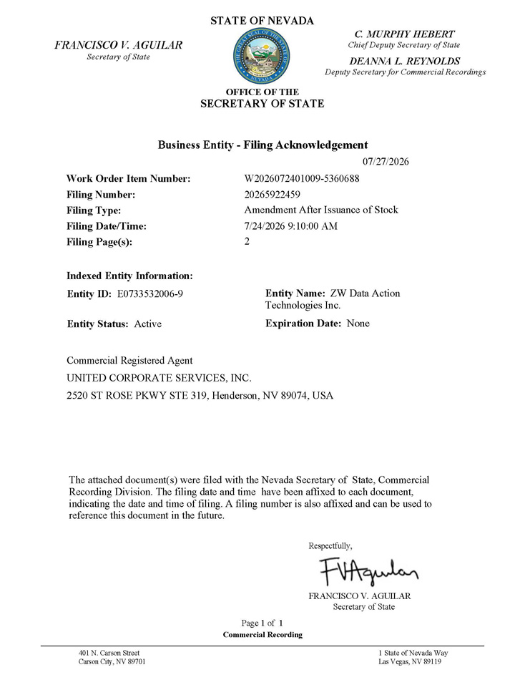
Work Order Item Number: Filing Number: Filing Type: Filing Date/Time: Filing Page(s): W2026072401009 - 5360688 20265922459 Amendment After Issuance of Stock 7/24/2026 9:10:00 AM 2 OFFICE OF THE SECRETARY OF STATE Business Entity - Filing Acknowledgement 07/27/2026 Indexed Entity Information: Entity ID: E0733532006 - 9 Entity Name: ZW Data Action Technologies Inc. Expiration Date: None Entity Status: Active Commercial Registered Agent UNITED CORPORATE SERVICES, INC. 2520 ST ROSE PKWY STE 319, Henderson, NV 89074, USA FRANCISCO V. AGUILAR Secretary of State STATE OF NEVADA C. MURPHY HEBERT Chief Deputy Secretary of State DEANNA L. REYNOLDS Deputy Secretary for Commercial Recordings The attached document(s) were filed with the Nevada Secretary of State, Commercial Recording Division. The filing date and time have been affixed to each document, indicating the date and time of filing. A filing number is also affixed and can be used to reference this document in the future. Respectfully, FRANCISCO V. AGUILAR Secretary of State Page 1 of 1 Commercial Recording 401 N. Carson Street Carson City, NV 89701 1 State of Nevada Way Las Vegas, NV 89119

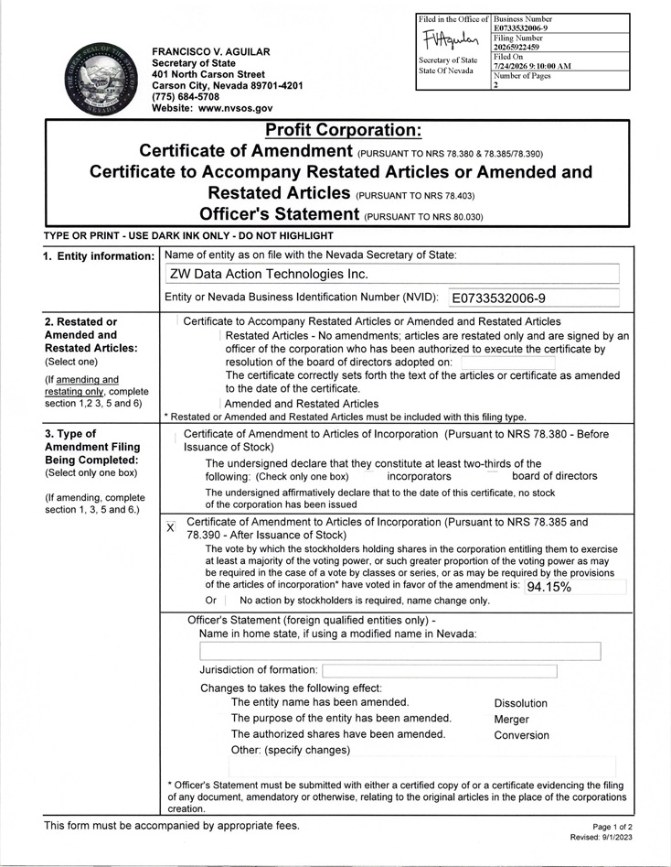
Business Number E0733532006 - 9 Filed in the Office of Filing Number 20265922459 Secretary of State State Of Nevada Filed On 7/24/2026 9:10:00 AM Number of Pages 2

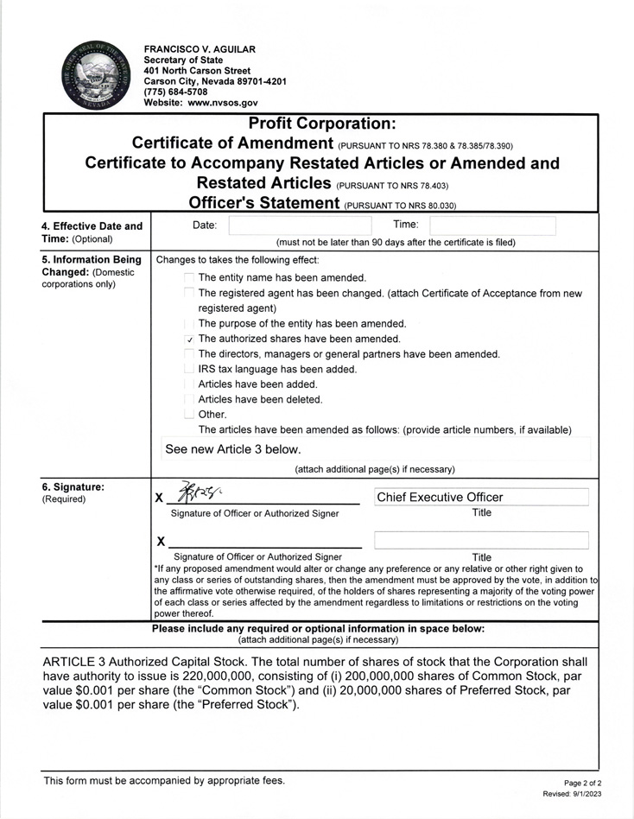
FRANCISCO V. AGUILAR Secretary of State 401 North Carson Street Carson City, Nevada 89701 - 4201 (775) 684 - 5708 Website: www.nvsos.gov 4 T 5 C c 6 ( Profit Corporation: Certificate of Amendment (PuRsuANT TO NRs 78.380 & 78 . 385/78 . 390) Certificate to Accompany Restated Articles or Amended and Restated Articles (PuRsuANTTO NRs 78.403) Officer's Statement (PURSUANT TO NRs 80.030) Date : ' Time : I (must not be later than 90 days after the certificate is filed) . Effective Date and ime: (Optional) Changes to takes the following effect: � The entity name has been amended. The registered agent has been changed . (attach Certificate of Acceptance from new registered agent) The purpose of the entity has been amended. ✓ The authorized shares have been amended. The directors , managers or general partners have been amended . IRS tax language has been added . Articles have been added . Articles have been deleted. � Other . The articles have been amended as follows : (provide article numbe r s , if available) See new Article 3 below. (attach additional page(s) if necessary) . Information Being hanged: (Domestic orporations only) x_ � - � - l _ Chief Executive Officer 1 Signature of Officer or Authorized Signer Title X Signature of Officer or Authorized Signer Title * If any proposed amendment would alter or change any preference or any relative or other right given to any class or series of outstanding shares , then the amendment must be approved by the vote , in addit i on to the affirmative vote otherwise required , of the holders of shares representing a majority of the voting power of each class or series affected by the amendment regardless to limitations or restrictions on the voting power thereof . . Signature: Required) Please include any required or optional information in space below: (attach additional page(s) if necessary) ARTICLE 3 Authorized Capital Stock. The total number of shares of stock that the Corporation shall have authority to issue is 220,000,000, consisting of (i) 200 , 000,000 shares of Common Stock , par value $0.001 per share (the " Common Stock " ) and (ii) 20,000,000 shares of Preferred Stock , par value $0.001 per share (the "Preferred Stock " ). This form must be accompanied by appropriate fees. Page 2 o f 2 Rev i sed : 9/ 1 / 2 0 2 3

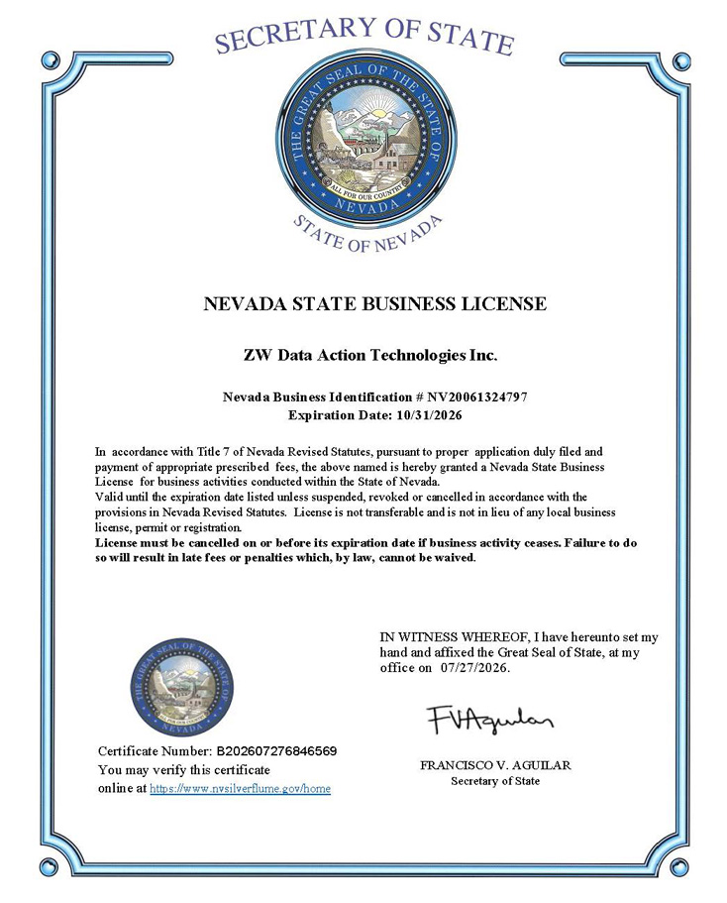
NEVADA STATE BUSINESS LICENSE ZW Data Action Technologies Inc. Nevada Business Identification # NV20061324797 Expiration Date: 10/31/2026 In accordance with Title 7 of Nevada Revised Statutes, pursuant to proper application duly filed and payment of appropriate prescribed fees, the above named is hereby granted a Nevada State Business License for business activities conducted within the State of Nevada . Valid until the expiration date listed unless suspended, revoked or cancelled in accordance with the provisions in Nevada Revised Statutes. License is not transferable and is not in lieu of any local business license, permit or registration. License must be cancelled on or before its expiration date if business activity ceases. Failure to do so will result in late fees or penalties which, by law, cannot be waived . Certificate Number: B202607276846569 You may verify this certificate online at https://www.nvsilverflume.gov/home IN WITNESS WHEREOF, I have hereunto set my hand and affixed the Great Seal of State, at my office on 07/27/2026. FRANCISCO V. AGUILAR Secretary of State

